

SRI LANKA INSTITUTE OF INFORMATION TECHNOLOGY

[**Enterprise Standards and Best Practices for IT Infrastructure**](http://courseweb.sliit.lk/course/view.php?id=137)

**4th Year 2nd Semester 2014**

**VMotion Migration**

Name: Priyaranga G.S.C.

SLIIT ID: IT13133078

Group Number:

Practical Session: WD

Practical Number: Lab 6

Date of Submission: 9/14/2016

Date of Evaluation : 9/14/2016

Evaluators Signature : ____________________

**VMotion Migration**

VMotion Migration is moving a running virtual machine (VM) from one host to another with zero downtime, continuous service availability and complete transaction integrity.

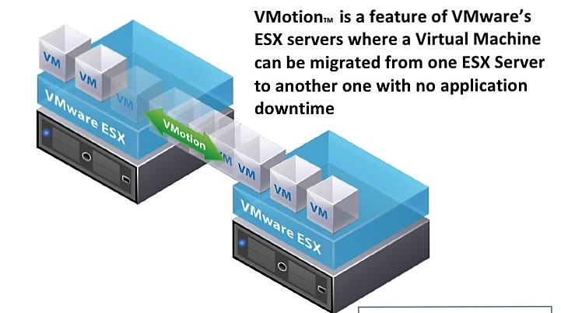

**How VMotion migration works,**

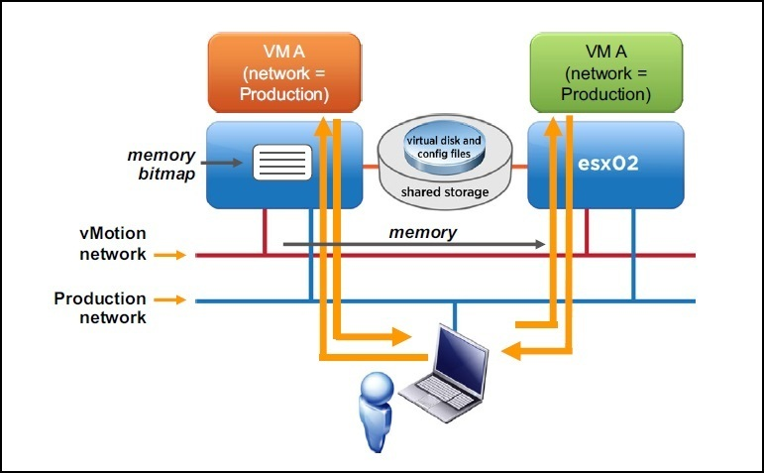

With VMotion, can change the host on which a virtual machine is running, or can change both the host and the data store of the virtual machine. To perform a VMotion there should be a shared storage for both hosts. Shared storage makes migration faster, because there is no need of copying any of the files. What actually need is copying the memory state of the virtual machine from first host to the second host. That performs across the VMotion network.

Hosts should have identical network configuration including identically spelled labels for the VM port groups for networks such as production network.

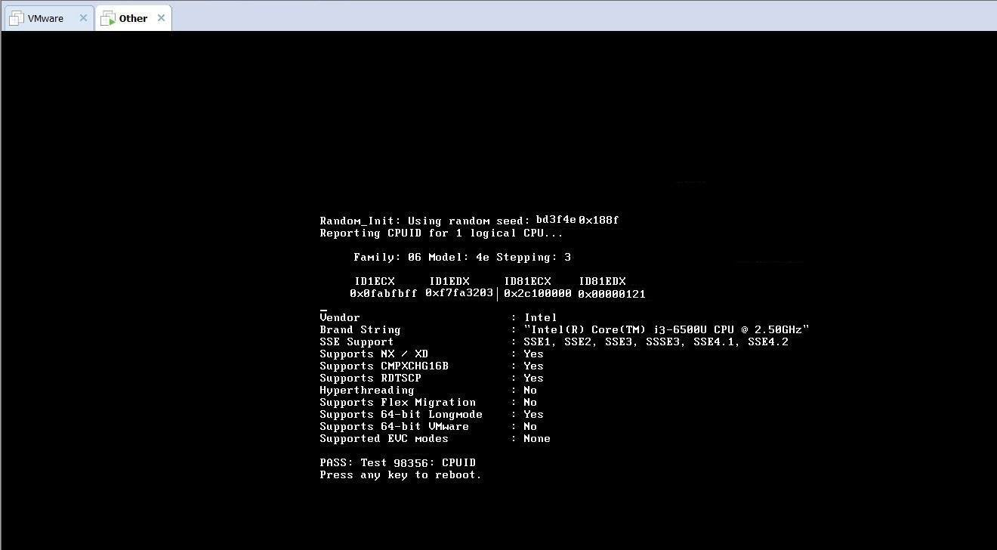

**Virtual Machines should have following requirements**.

* VM must not have a connection to virtual devices (eg: CD-Rom) with a local image mounted.
* VM must not have a connection to an internal switch.
* VM must not have CPU affinity configured.
* VM with USB pass through devices can be migrated with vMotion as long as the devices are enabled for vMotion

**Hosts should have following requirements.**

* Visibility to all storage used by the VM. (Fiber channel, iSCSI, NAS)
* At least a Gigabit Ethernet network.(faster the network more concurrent vMotion migrations allows)
* Access to same physical networks.
* Compatible CPUs. Using VMware CPU identification utility, CPU characteristic can be identified. Comparing the reports for both hosts Incompatibilities can be detected.

**VMotion migration benefits are,**

* Improve overall hardware utilization.
* Allow continued virtual machine operation while accommodating scheduled hardware downtime.
* Allows VSphere Distributed Resource Scheduler (DRS) to balance VMs across hosts.
* Continuously and automatically allocate virtual machines within resource pools.
* Improve availability by conducting maintenance without disrupting business operations